RB Rail AS Organisational Structure With Units
RBGL-RBR-CHA-Z-00002 Rev.1.0
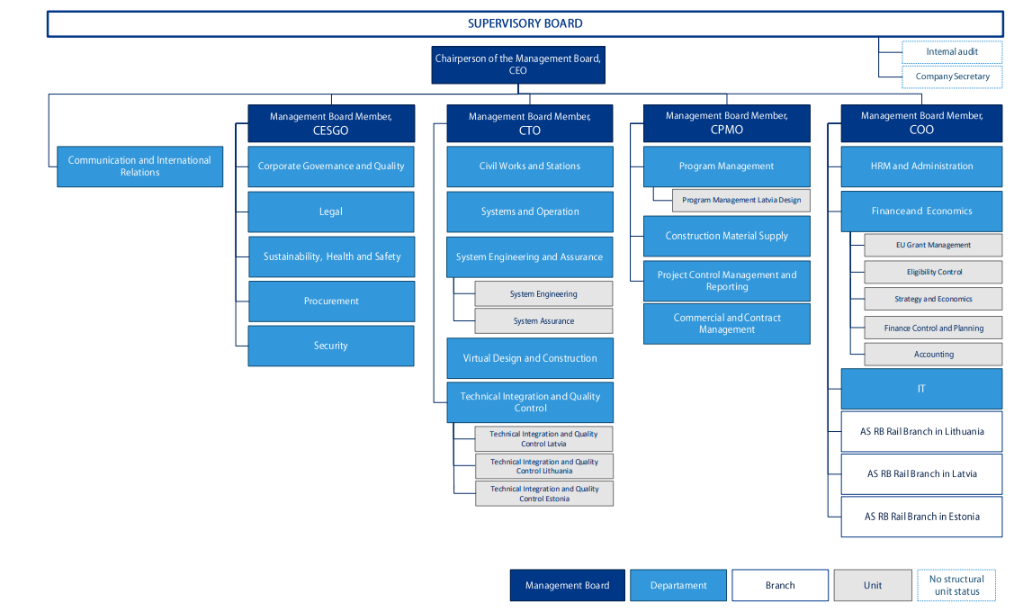
Approved by RB Rail AS management Board decision No.7/48/2024, date 20.06.2024. and RB Rail AS Supervisory Board, decision No.5/216/2024, date 06.06.2024.

