Pielikums
Ministru kabineta
2021. gada
rīkojumam Nr.

Atkrastes vēja parka un elektropārvades kabeļu koridora licences laukuma karte
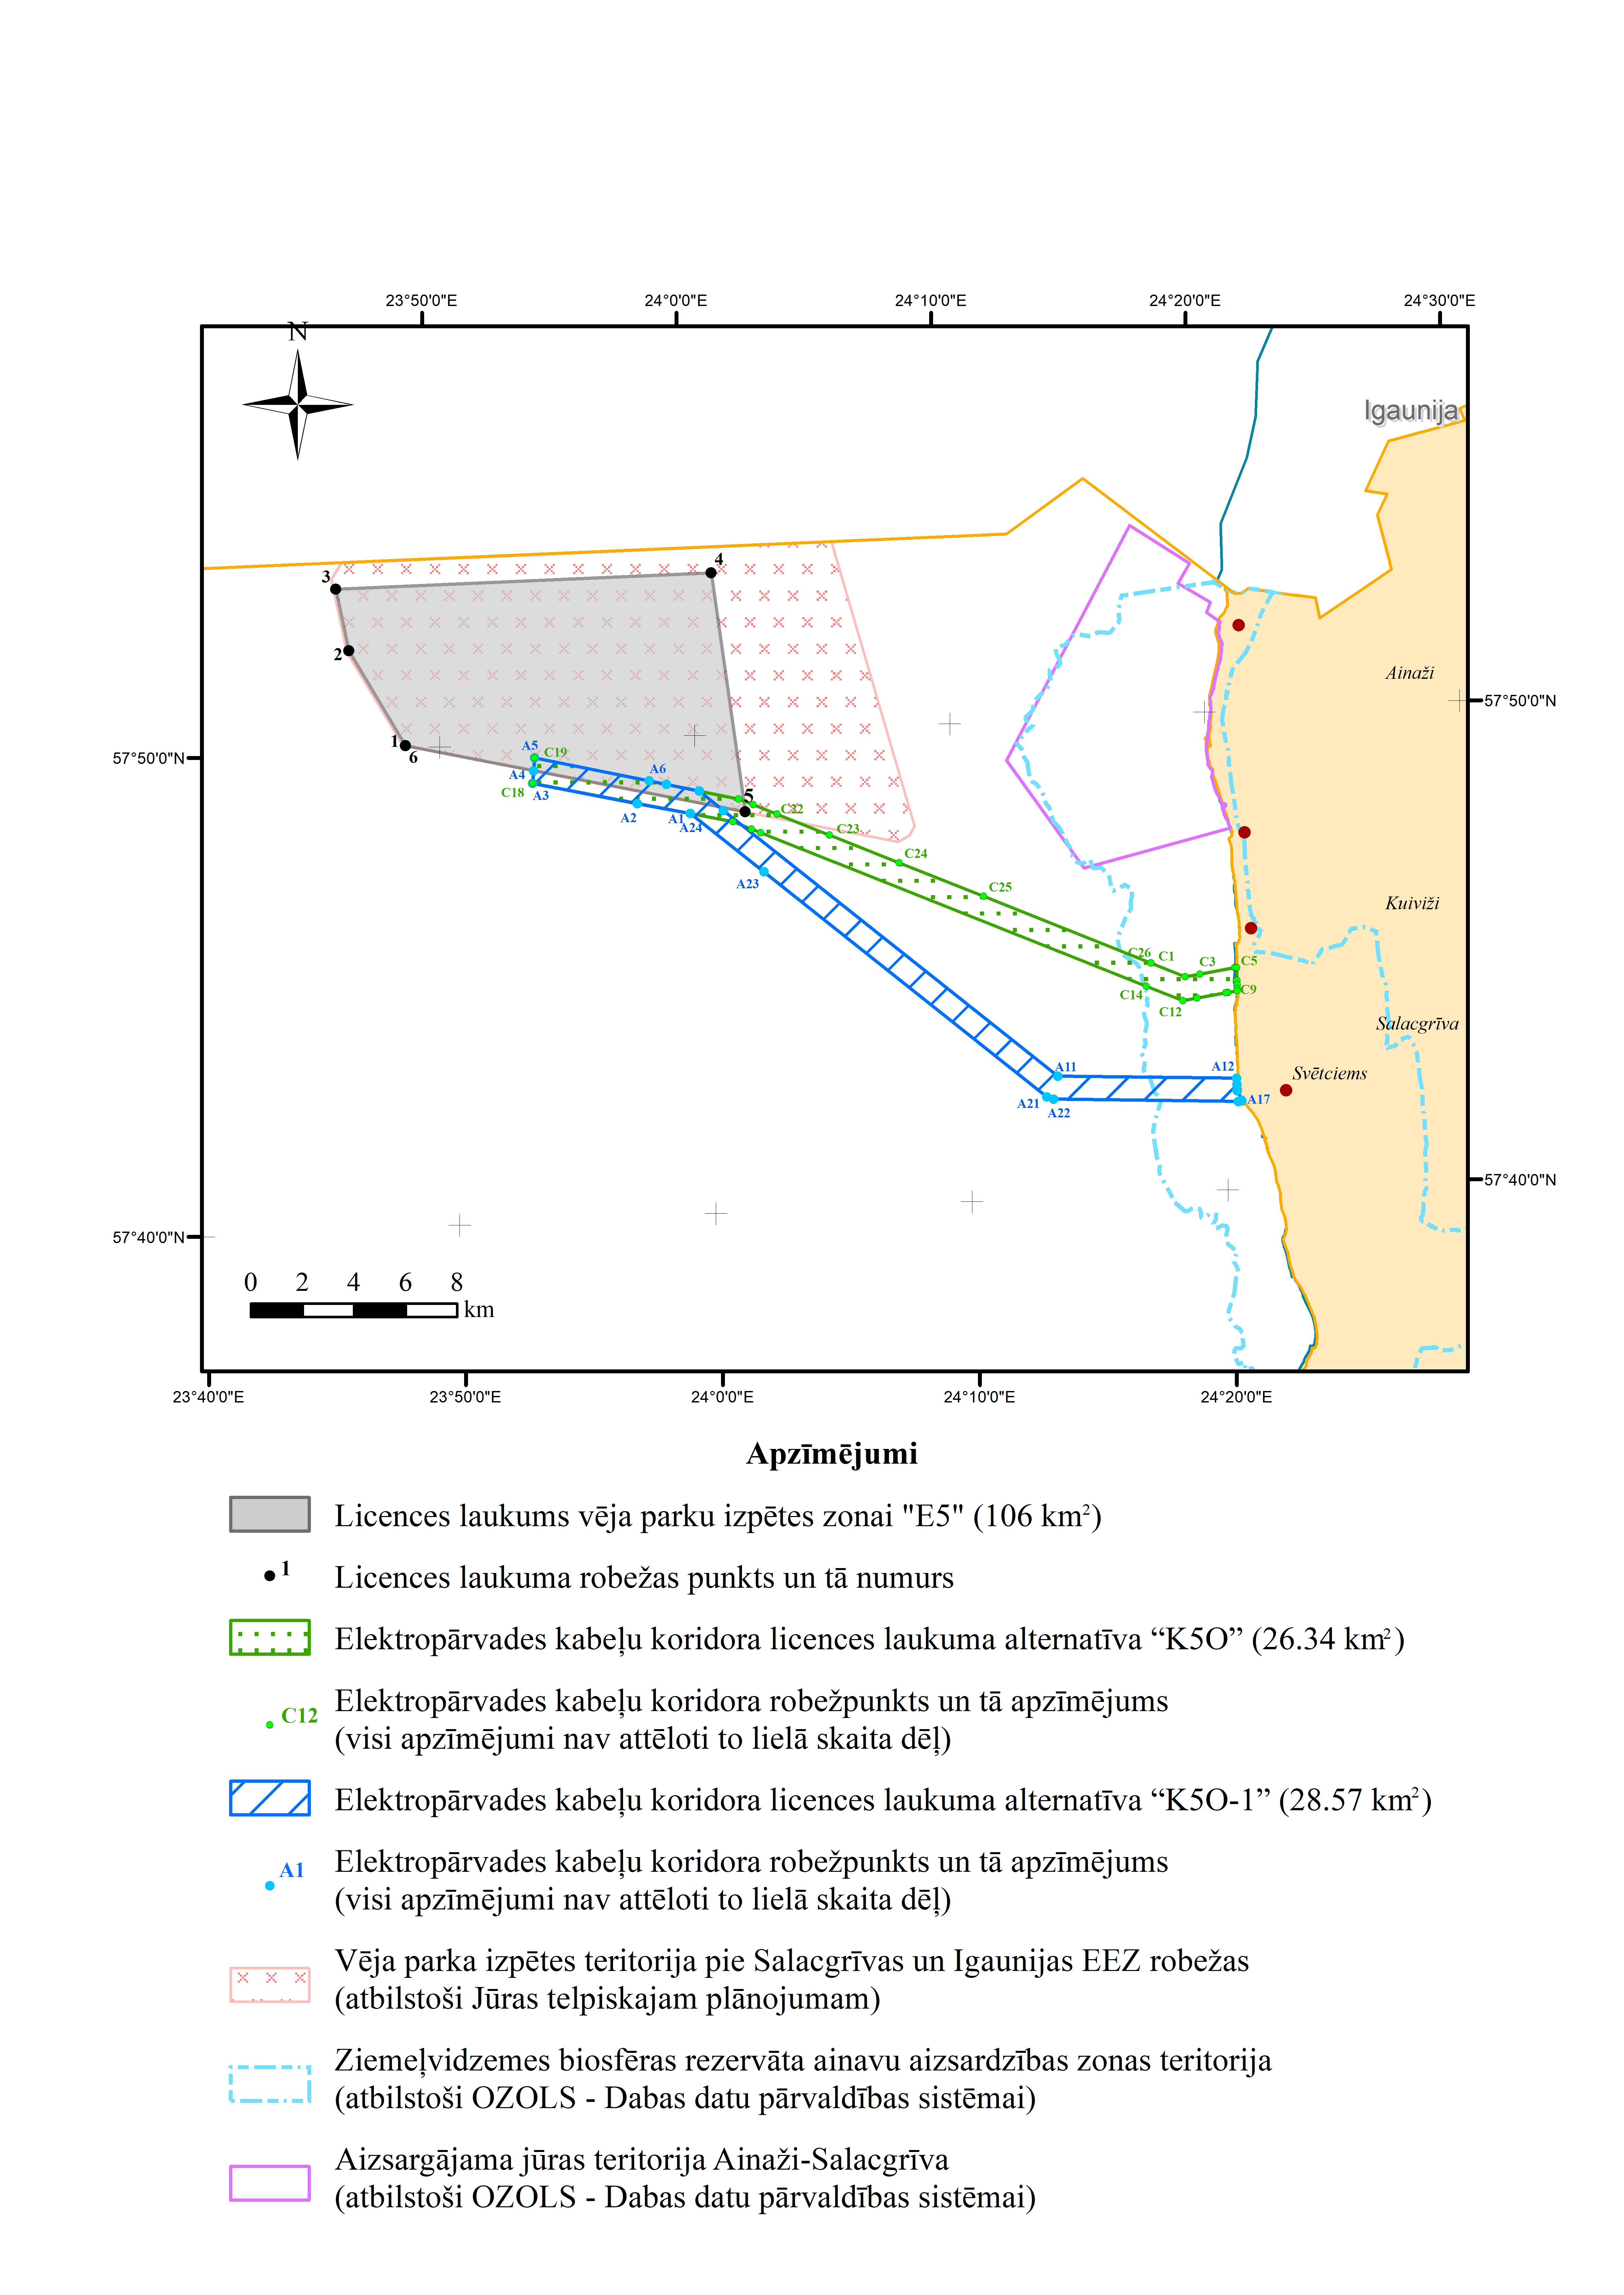
Atkrastes vēja parka laukuma “E5O” robežpunktu koordinātas
Robežp. Nr. | LKS 1992 |  | WGS84
Robežp. Nr. | Austrumi | Ziemeļi | Platums (Dd) | Garums (Dd) | Platums (DMS) | Garums (DMS)
1 | 488783 | 410334 | 57.834801 | 23.811101 | 57° 50' 5.283" N | 23° 48' 39.962" E
2 | 486751 | 414104 | 57.868612 | 23.776670 | 57° 52' 7.003" N | 23° 46' 36.011" E
3 | 486347 | 416513 | 57.890238 | 23.769720 | 57° 53' 24.856" N | 23° 46' 10.993" E
4 | 500925 | 416495 | 57.890285 | 24.015603 | 57° 53' 25.024" N | 24° 0' 56.172" E
5 | 501828 | 407179 | 57.806597 | 24.030759 | 57° 48' 23.748" N | 24° 1' 50.733" E
6 | 488783 | 410334 | 57.834801 | 23.811101 | 57° 50' 5.283" N | 23° 48' 39.962" E

Elektropārvades kabeļu koridora licences laukuma alternatīva “K5O”
Robežp. Nr. | LKS-92 |  | WGS84
Robežp. Nr. | Austrumi | Ziemeļi | Platums (Dd) | Garums (Dd) | Platums (DMS) | Garums (DMS)
C1 | 517276.85 | 400624.21 | 57.747393 | 24.290246 | 57°44' 50.615" N | 24° 17' 24.887" E
C2 | 518584.55 | 400034.94 | 57.742048 | 24.312169 | 57° 44' 31.372" N | 24° 18' 43.809" E
C3 | 519150.42 | 400112.59 | 57.742721 | 24.321680 | 57° 44' 33.797" N | 24° 19' 18.050" E
C4 | 520516.38 | 400300.04 | 57.744345 | 24.344641 | 57° 44' 39.642" N | 24° 20' 40.707" E
C5 | 520591.19 | 400304.63 | 57.744383 | 24.345898 | 57° 44' 39.778" N | 24° 20' 45.233" E
C6 | 520584.33 | 399804.92 | 57.739894 | 24.345740 | 57° 44' 23.620" N | 24° 20' 44.663" E
C7 | 520582.12 | 399643.96 | 57.738449 | 24.345689 | 57° 44' 18.416" N | 24° 20' 44.480" E
C8 | 520579.91 | 399483.01 | 57.737003 | 24.345638 | 57° 44' 13.211" N | 24° 20' 44.297" E
C9 | 520578.78 | 399400.61 | 57.736263 | 24.345612 | 57° 44' 10.547" N | 24° 20' 44.203" E
C10 | 520215.98 | 399350.82 | 57.735832 | 24.339515 | 57° 44' 8.996" N | 24° 20' 22.253" E
C11 | 520121.12 | 399337.80 | 57.735720 | 24.337921 | 57° 44' 8.591" N | 24° 20' 16.514" E
C12 | 519000.22 | 399183.98 | 57.734387 | 24.319084 | 57° 44' 3.792" N | 24° 19' 8.703" E
C13 | 518446.53 | 399107.99 | 57.733727 | 24.309780 | 57° 44' 1.418" N | 24° 18' 35.207" E
C14 | 517056.50 | 399736.81 | 57.739431 | 24.286482 | 57° 44' 21.950" N | 24° 17' 11.334" E
C15 | 502391.01 | 406345.58 | 57.799111 | 24.040226 | 57° 47' 56.798" N | 24° 2' 24.812" E
C16 | 502047.80 | 406500.25 | 57.800502 | 24.034453 | 57° 48' 1.806" N | 24° 2' 4.030" E
C17 | 501336.80 | 406820.66 | 57.803382 | 24.022493 | 57° 48' 12.176" N | 24° 1' 20.973" E
C18 | 493629.43 | 408647.35 | 57.819747 | 23.892762 | 57° 49' 11.089" N | 23° 53' 33.944" E
C19 | 493754.71 | 409642.15 | 57.828684 | 23.894845 | 57° 49' 43.263" N | 23° 53' 41.442" E
C20 | 501589.61 | 407693.51 | 57.811222 | 24.026752 | 57° 48' 40.398" N | 24° 1' 36.307" E
C21 | 502144.02 | 407443.66 | 57.808975 | 24.036080 | 57° 48' 32.310" N | 24° 2' 9.889" E
C22 | 503045.55 | 407037.38 | 57.805321 | 24.051246 | 57° 48' 19.154" N | 24° 3' 4.487" E
C23 | 505035.49 | 406140.61 | 57.797248 | 24.084711 | 57° 47' 50.091" N | 24° 5' 4.961" E
C24 | 507688.13 | 404945.21 | 57.786472 | 24.129298 | 57° 47' 11.301" N | 24° 7' 45.472" E
C25 | 510901.98 | 403496.92 | 57.773397 | 24.183282 | 57° 46' 24.228" N | 24° 10' 59.814" E
C26 | 517276.85 | 400624.21 | 57.747393 | 24.290246 | 57° 44' 50.615" N | 24° 17' 24.887" E

Elektropārvades kabeļu koridora licences laukuma alternatīva “K5O-1”
Robežpunkta Nr. | LKS-92 |  | WGS84
Robežpunkta Nr. | Austrumi | Ziemeļi | Platums (Dd) | Garums (Dd) | Platums (DMS) | Garums (DMS)
A1 | 499693.53 | 407209.20 | 57.806874 | 23.994843 | 57° 48' 24.747" N | 23° 59' 41.435" E
A2 | 497655.36 | 407691.13 | 57.811197 | 23.960541 | 57° 48' 40.309" N | 23° 57' 37.949" E
A3 | 493629.43 | 408647.35 | 57.819747 | 23.892762 | 57° 49' 11.089" N | 23° 53' 33.944" E
A4 | 493691.03 | 409136.51 | 57.824142 | 23.893786 | 57° 49' 26.909" N | 23° 53' 37.630" E
A5 | 493754.71 | 409642.15 | 57.828684 | 23.894845 | 57° 49' 43.263" N | 23° 53' 41.442" E
A6 | 498153.18 | 408548.19 | 57.818898 | 23.968913 | 57° 49' 8.032" N | 23° 58' 8.085" E
A7 | 498816.98 | 408383.09 | 57.817417 | 23.980087 | 57° 49' 2.701" N | 23° 58' 48.314" E
A8 | 500074.08 | 408070.44 | 57.814610 | 24.001247 | 57° 48' 52.597" N | 24° 0' 4.489" E
A9 | 500087.26 | 408058.99 | 57.814507 | 24.001469 | 57° 48' 52.226" N | 24° 0' 5.287" E
A10 | 500987.66 | 407276.30 | 57.807476 | 24.016620 | 57° 48' 26.913" N | 24° 0' 59.832" E
A11 | 513482.03 | 396415.84 | 57.709722 | 24.226259 | 57° 42' 34.999" N | 24° 13' 34.532" E
A12 | 520398.99 | 396028.38 | 57.705981 | 24.342307 | 57° 42' 21.531" N | 24° 20' 32.303" E
A13 | 520402.13 | 395785.17 | 57.703796 | 24.342339 | 57° 42' 13.666" N | 24° 20' 32.419" E
A14 | 520404.81 | 395577.56 | 57.701931 | 24.342366 | 57° 42' 6.953" N | 24° 20' 32.517" E
A15 | 520405.21 | 395546.48 | 57.701652 | 24.342370 | 57° 42' 5.947" N | 24° 20' 32.532" E
A16 | 520545.35 | 395171.79 | 57.698280 | 24.344689 | 57° 41' 53.808" N | 24° 20' 40.882" E
A17 | 520558.89 | 395138.91 | 57.697984 | 24.344914 | 57° 41' 52.743" N | 24° 20' 41.689" E
A18 | 520452.87 | 395125.32 | 57.697867 | 24.343134 | 57° 41' 52.321" N | 24° 20' 35.282" E
A19 | 520433.90 | 395125.56 | 57.697870 | 24.342816 | 57° 41' 52.332" N | 24° 20' 34.136" E
A20 | 520423.92 | 395126.00 | 57.697874 | 24.342648 | 57° 41' 52.348" N | 24° 20' 33.533" E
A21 | 513278.00 | 395526.27 | 57.701737 | 24.222786 | 57° 42' 6.255" N | 24° 13' 22.029" E
A22 | 513008.08 | 395635.88 | 57.702730 | 24.218263 | 57° 42' 9.827" N | 24° 13' 5.747" E
A23 | 502436.52 | 404824.84 | 57.785450 | 24.040976 | 57° 47' 7.622" N | 24° 2' 27.513" E
A24 | 499693.53 | 407209.20 | 57.806874 | 23.994843 | 57° 48' 24.747" N | 23° 59' 41.435" E

Ekonomikas ministrs J. Vitenbergs

